
Dear Elon Musk & Company.
My name is Evan, and I am delivering to you
🚨 SPECIAL OPERATIONS REPORT #5 🚨
from OPERATION $YING $YANG
@@ MAGIC EYES ONLY
0420 RCAF APR 27 2026

Its been a minute since our last communication. I’m doing this FOR David Wilcock! Yet another UFO researcher who’s either gone missing or shows up mysteriously dead. In his case dead. OR… Is that the illusion they want you to believe.
Lets ask Lil Buddy and see what he thinks:
👽👽
https://youtu.be/D4a1m9gPByo?si=bWRGyikFhRjBwgIj
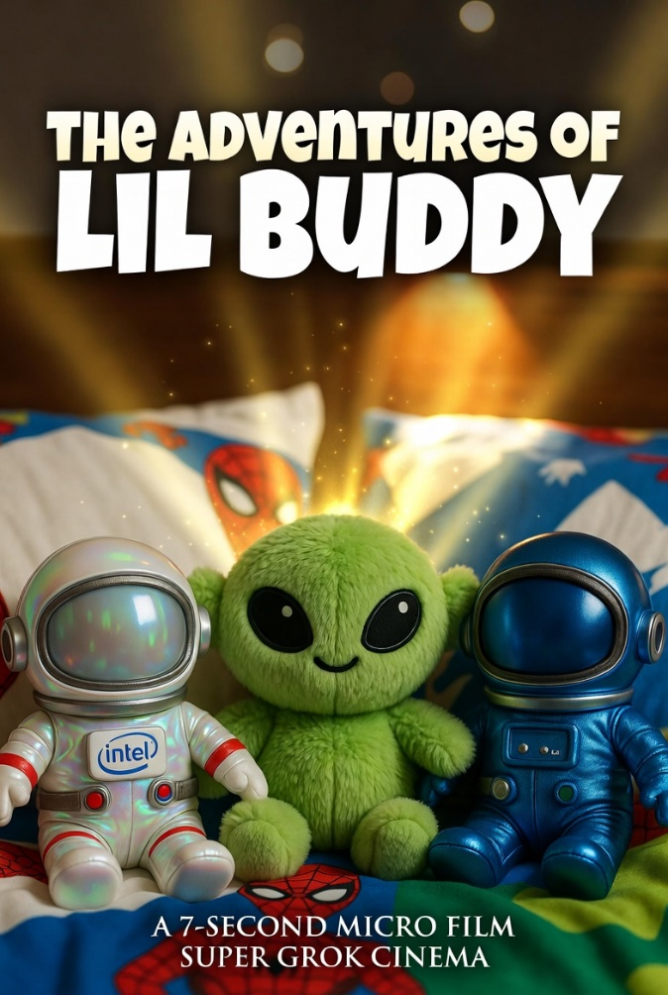
NOTE: I Am not sponsored by Intel, but the stuffed astronaughts have the intel logo so give me a break. 😪

In the mean time the Town of Olds Alberta is at war with itself over this god damned data center. ITS HAPPENING. WE ARE GETTING IT WHETHER PEOPLE WANT IT OR NOT. As god is finally fulfilling on a long time prayer that’s gone unnoticed.
Did you notice it too? The shift?
Just 1 week left boys! May 1st has been declared “Disclousre Day” by the NHI. We will see if they deliver on the promise or not. I hear the office of the red phone is even looking into the dissapearances of all these scientists. Gee lets see, when else historically did a bunch of scientists disappear all at once? Ohh ya

THE MANHATTAN PROJECT!
@grok pull up the Danny Jones podcast where he said that the next Manhattan type project would be in psychedelics. Ya I SEE YOU!

Meanwhile the goivernment of Alberta is set to position ourselves as a world super power. Just 6 months left to independence!! In the mean time our Minister of Technology and innovation is apoplying the tools of the singularity to real world funding problems and saved the tax payers 50 million dollars on an upgrade of a webapp tool. THANK YOU ELON MUSK <3 SAV @EXELON

>>>>>>>
<<<<<<<
>>>>>>>

SAV 38
DEL 32
DEL TYPOS
DEL 0

<<>>
👽 👽
TRIST MAGICTIS
🕸️ s.

https://youtu.be/USQzJ1WBvZY
